**APPLIED DATA**

**SCIENCE**

PYTHON NUMPY AND PANDAS BASICS

ASSSIGNMENT-1

DONE BY.,

X.DIALING DIJOE

REG:961819106019

BATCH:B12-6A2E

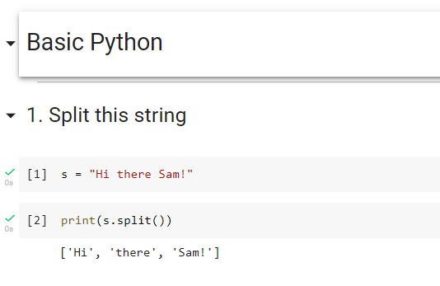

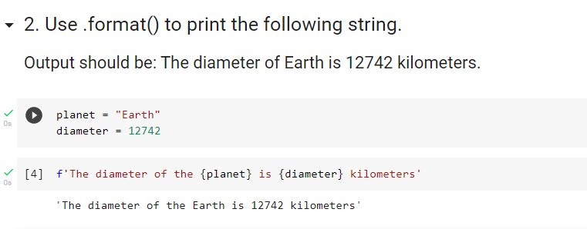

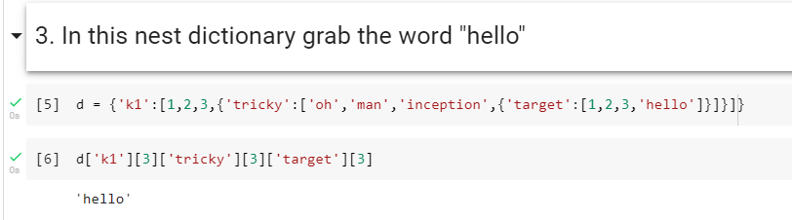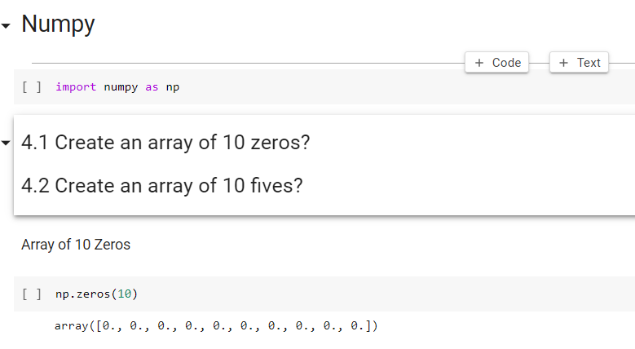

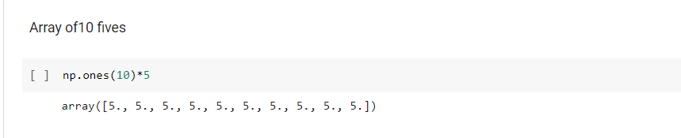

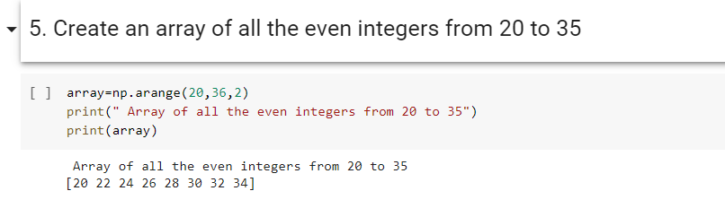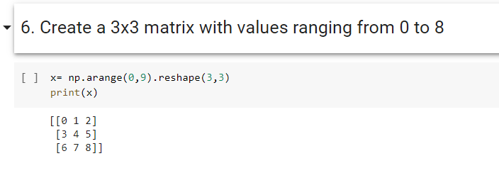

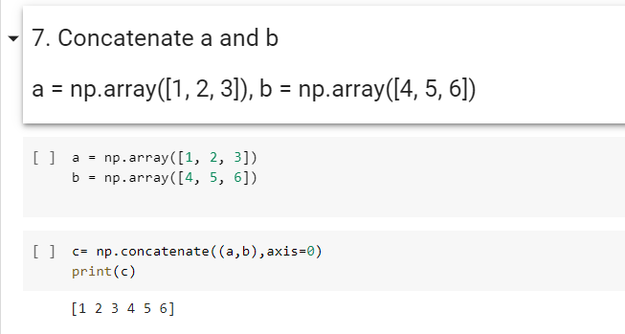

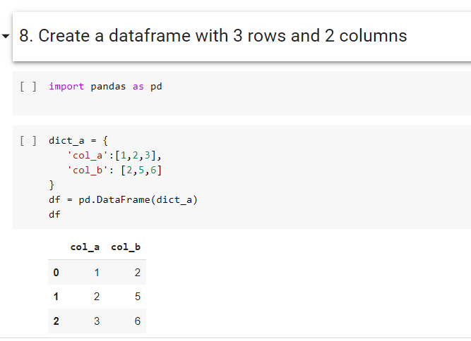

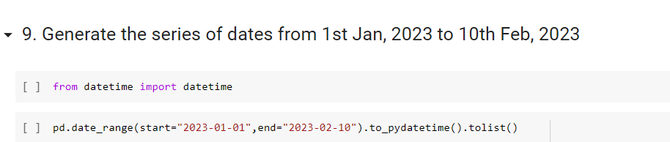

[datetime.datetime(2023, 1, 1, 0, 0),

datetime.datetime(2023, 1, 2, 0, 0),

datetime.datetime(2023, 1, 3, 0, 0),

datetime.datetime(2023, 1, 4, 0, 0),

datetime.datetime(2023, 1, 5, 0, 0),

datetime.datetime(2023, 1, 6, 0, 0),

datetime.datetime(2023, 1, 7, 0, 0),

datetime.datetime(2023, 1, 8, 0, 0),

datetime.datetime(2023, 1, 9, 0, 0),

datetime.datetime(2023, 1, 10, 0, 0),

datetime.datetime(2023, 1, 11, 0, 0),

datetime.datetime(2023, 1, 12, 0, 0),

datetime.datetime(2023, 1, 13, 0, 0),

datetime.datetime(2023, 1, 14, 0, 0),

datetime.datetime(2023, 1, 15, 0, 0),

datetime.datetime(2023, 1, 16, 0, 0),

datetime.datetime(2023, 1, 17, 0, 0),

datetime.datetime(2023, 1, 18, 0, 0),

datetime.datetime(2023, 1, 19, 0, 0),

datetime.datetime(2023, 1, 20, 0, 0),

datetime.datetime(2023, 1, 21, 0, 0),

datetime.datetime(2023, 1, 22, 0, 0),

datetime.datetime(2023, 1, 23, 0, 0),

datetime.datetime(2023, 1, 24, 0, 0),

datetime.datetime(2023, 1, 25, 0, 0),

datetime.datetime(2023, 1, 26, 0, 0),

datetime.datetime(2023, 1, 27, 0, 0),

datetime.datetime(2023, 1, 28, 0, 0),

datetime.datetime(2023, 1, 29, 0, 0),

datetime.datetime(2023, 1, 30, 0, 0),

datetime.datetime(2023, 1, 31, 0, 0),

datetime.datetime(2023, 2, 1, 0, 0),

datetime.datetime(2023, 2, 2, 0, 0),

datetime.datetime(2023, 2, 3, 0, 0),

datetime.datetime(2023, 2, 4, 0, 0),

datetime.datetime(2023, 2, 5, 0, 0),

datetime.datetime(2023, 2, 6, 0, 0),

datetime.datetime(2023, 2, 7, 0, 0),

datetime.datetime(2023, 2, 8, 0, 0),

datetime.datetime(2023, 2, 9, 0, 0),

datetime.datetime(2023, 2, 10, 0, 0)]

